VOLTAGE CONVERTER (MAX232)

The MAX220–MAX249 family of line drivers/receivers is intended for all EIA/TIA-232E and V.28/V.24 communications interfaces, particularly applications where ±12V is not available. These parts are especially useful in battery-powered systems, since their low-power shutdown mode reduces power dissipation to less than 5μW.

Feature

- Operate from Single +5V Power Supply
- Low-Power Receive Mode in Shutdown
- Meet All EIA/TIA-232E and V.28 Specifications
- Multiple Drivers and Receivers
- 3-State Driver and Receiver Outputs

3.3.1 PIN Diagram

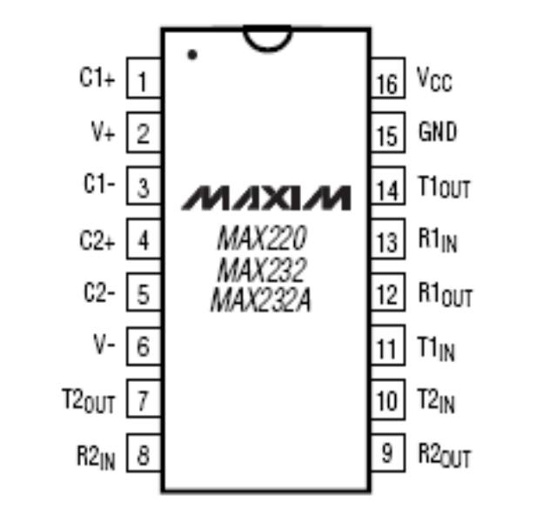

Figure.3.6 Pin Diagram of MAX232

Since the RS232 is not compatible with today’s microprocessors and microcontrollers, we need a line driver (voltage converter) to convert the RS232’s signals to TTL voltage levels that will be acceptable to the 8051’s TxD and RxD pins. One example of such a converter is MAX232 from Maxim Corp. The MAX 232 converts from RS232 voltage levels to TTL voltage levels, and vice versa. One advantage of the MAX232 chip is that it uses a+5V power source which is the same as the source voltage for the 8051. In other words, with a single +5 V power supply we can power both the 80551 and MAX232, with no need for the dual power supplies that are common in many older systems.

Functional Diagram of MAX232
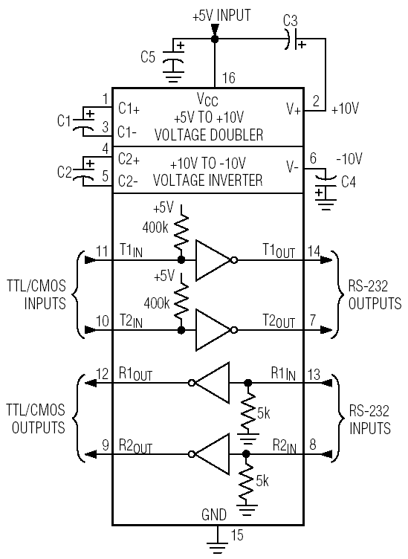

Figure.3.7 Functional Diagram of MAX232
The MAX232 has two sets of line drivers for transferring and receiving data, as shown in Figure 10-7. The line drivers used for TxD are called T1 and T2 while the line drivers for Rxd are designated as R1 and R2. In many applications only one of each is used for example, T1 and R1 are used together for TxD and RxD of the 8051 and the second set is left unused. Notice in MAX232 that the T1 line driver has a designation of T1 in and T1 out on pin numbers 11 and 14, respectively. The T1 in pin is the TTL side and is connected to TxD of the microcontroller, while T1 out is the RS232 side that is connected to the RxD pin of the RS232 DB connector.
The R1 line driver has a designation of R1 in and R iout on pin numbers 13 and 12, respectively. The R1 in (pin 13) is the RS232 side that is connected to the TxD pin of the RS232 DB connector, and R1 out (pin 12) is the TTL side that is connected to the RxD pin of the microcontroller. See figure 10-7. Notice the null modem connection where RxD for one is TxD for the other.

MAX232 requires four capacitors ranging from 1 to 22F. The most widely used value for these capacitors is 22nf.

APPLICATIONS

- Portable Computers
- Low-Power Modems
- Interface Translation
- Battery-Powered RS-232 Systems
- Multidrop RS-232 Networks

Serial Ports in Computer

All IBM PC and compatible computers are typically equipped with two serial ports and one parallel port. Although these two types of ports are used for communicating with external devices, they work in different ways.

A parallel port sends and receives data eight bits at a time over 8 separate wires. This allows data to be transferred very quickly; however, the cable required is more bulky because of the number of individual wires it must contain. Parallel ports are typically used to connect a PC to a printer and are rarely used for much else. A serial port sends and receives data one bit at a time over one wire. While it takes eight times as long to transfer each byte of data this way, only a few wires are required. In fact, two-way (full duplex) communications is possible with only three separate wires - one to send, one to receive, and a common signal ground wire.

Introduction to Serial Port

The UART serial port (or just "serial port for short" is an I/O (Input/Output) device. An I/O device is just a way to get data into and out of a computer. There are many types of I/O devices such as serial ports, parallel ports, disk drive controllers, ethernet boards, universal serial buses, etc. Most PC's have one or two serial ports. Each has a 9-pin connector (sometimes 25-pin) on the back of the computer. Computer programs can send data (bytes) to the transmit pin (output) and receive bytes from the receive pin (input). The other pins are for control purposes and ground.

The serial port is much more than just a connector. It converts the data from parallel to serial and changes the electrical representation of the data. Inside the computer, data bits flow in parallel (using many wires at the same time). Serial flow is a stream of bits over a single wire (such as on the transmit or receive pin of the serial connector). For the serial port to create such a flow, it must convert data from parallel (inside the computer) to serial on the transmit pin (and conversely).

Pins and Wires

Old PC's used 25 pin connectors but only about 9 pins were actually used so today most connectors are only 9-pin. Each of the 9 pins usually connects to a wire. Besides the two wires used for transmitting and receiving data, another pin (wire) is signal ground. The voltage on any wire is measured with respect to this ground.

Thus the minimum number of wires to use for 2-way transmission of data is 3. Except that it has been known to work with no signal ground wire but with degraded performance and sometimes with errors. There are still more wires which are for control purposes (signaling) only and not for sending bytes. All of these signals could have been shared on a single wire, but instead, there is a separate dedicated wire for every type of signal. Some (or all) of these control wires are called "modem control lines". Modem control wires are either in the asserted state (on) of +12 volts or in the negated state (off) of -12 volts. One of these wires is to signal the computer to stop sending bytes out the serial port cable. Conversely, another wire signals the device attached to the serial port to stop sending bytes to the computer. If the attached device is a modem, other wires may tell the modem to hang up the telephone line or tell the computer that a connection has been made or that the telephone line is ringing (someone is attempting to call in).

Bi-Directional Communications

The serial port on your PC is a full-duplex device meaning that it can send and receive data at the same time. In order to be able to do this, it uses separate lines for transmitting and receiving data. Some types of serial devices support only one-way communications and therefore use only two wires in the cable - the transmit line and the signal ground.
Communicating By Bits

Once the start bit has been sent, the transmitter sends the actual data bits. There may either be 5, 6, 7, or 8 data bits, depending on the number you have selected. Both receiver and the transmitter must agree on the number of data bits, as well as the baud rate. Almost all devices transmit data using either 7 or 8 data bits. Notice that when only 7 data bits are employed, you cannot send ASCII values greater than 127. Likewise, using 5 bits limits the highest possible value to 31. After the data has been transmitted, a stop bit is sent. A stop bit has a value of 1 - or a mark state - and it can be detected correctly even if the previous data bit also had a value of 1. This is accomplished by the stop bit's duration. Stop bits can be 1, 1.5, or 2 bit periods in length.

The Parity Bit

Besides the synchronization provided by the use of start and stop bits, an additional bit called a parity bit may optionally be transmitted along with the data. A parity bit affords a small amount of error checking, to help detect data corruption that might occur during transmission. You can choose even parity, odd parity, mark parity, space parity or none at all. When even or odd parity is being used, the number of marks (logical 1 bits) in each data byte is counted, and a single bit is transmitted following the data bits to indicate whether the number of 1 bits just sent is even or odd.
For example, when even parity is chosen, the parity bit is transmitted with a value of 0 if the number of preceding marks is an even number. For the binary value of 0110 0011 the parity bit would be 0. If even parity was in effect and the binary number 1101 0110 was sent, then the parity bit would be 1. Odd parity is just the opposite, and the parity bit is 0 when the number of mark bits in the preceding word is an odd number. Parity error checking is very rudimentary. While it will tell you if there is a single bit error in the character, it doesn't show which bit was received in error. Also, if even numbers of bits are in error then the parity bit would not reflect any error at all.
Mark parity means that the parity bit is always set to the mark signal condition and likewise space parity always sends the parity bit in the space signal condition. Since these two parity options serve no useful purpose whatsoever, they are almost never used.

RS-232C

RS-232 stands for Recommend Standard number 232 and C is the latest revision of the standard. The serial ports on most computers use a subset of the RS-232C standard. The full RS-232C standard specifies a 25-pin "D" connector of which 22 pins are used. Most of these pins are not needed for normal PC communications, and indeed, most new PCs are equipped with male D type connectors having only 9 pins.

Pin Details of PC Serial port

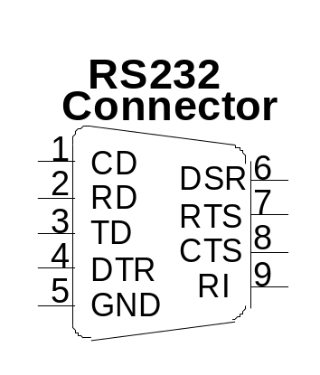

 | 9 Pin Connector on a DTE device (PC connection)
Pin Number | Direction of signal:
1 | Carrier Detect (CD) (from DCE) Incoming signal from a modem
2 | Received Data (RD) Incoming Data from a DCE
3 | Transmitted Data (TD) Outgoing Data to a DCE
4 | Data Terminal Ready (DTR) Outgoing handshaking signal
5 | Signal Ground Common reference voltage
6 | Data Set Ready (DSR) Incoming handshaking signal
7 | Request To Send (RTS) Outgoing flow control signal
8 | Clear To Send (CTS) Incoming flow control signal
9 | Ring Indicator (RI) (from DCE) Incoming signal from a modem

Table 4.1: Pins of RS232

The TD (transmit data) wire is the one through which data from a DTE device is transmitted to a DCE device. This name can be deceiving, because this wire is used by a DCE device to receive its data. The TD line is kept in a mark condition by the DTE device when it is idle. The RD (receive data) wire is the one on which data is received by a DTE device. RTS stands for Request To Send. This line and the CTS line are used when "hardware flow control" is enabled in both the DTE and DCE devices.

The DTE device puts this line in a mark condition to tell the remote device that it is ready and able to receive data. If the DTE device is not able to receive data (typically because its receive buffer is almost full), it will put this line in the space condition as a signal to the DCE to stop sending data. When the DTE device is ready to receive more data (i.e. after data has been removed from it’s receive buffer), it will place this line back in the mark condition. The complement of the RTS wire is CTS, which stands for Clear to Send. The DCE device puts this line in a mark condition to tell the DTE device that it is ready to receive the data.

Likewise, if the DCE device is unable to receive data, it will place this line in the space condition. Together, these two lines make up what is called RTS/CTS or "hardware" flow control. The Software Wedge supports this type of flow control, as well as Xon/XOff or "software" flow control. Software flow control uses special control characters transmitted from one device to another to tell the other device to stop or start sending data. With software flow control the RTS and CTS lines are not used.

DTR stands for Data Terminal Ready. Its intended function is very similar to the RTS line. DSR (Data Set Ready) is the companion to DTR in the same way that CTS is to RTS. Some serial devices use DTR and DSR as signals to simply confirm that a device is connected and is turned on. The Software Wedge sets DTR to the mark state when the serial port is opened and leaves it in that state until the port is closed. The DTR and DSR lines were originally designed to provide an alternate method of hardware handshaking. It would be pointless to use both RTS/CTS and DTR/DSR for flow control signals at the same time. Because of this, DTR and DSR are rarely used for flow control.

CD stands for Carrier Detect. Carrier Detect is used by a modem to signal that it has a made a connection with another modem, or has detected a carrier tone.

The last remaining line is RI or Ring Indicator. A modem toggles the state of this line when an incoming call rings your phone.
The Carrier Detect (CD) and the Ring Indicator (RI) lines are only available in connections to a modem. Because most modems transmit status information to a PC when either a carrier signal is detected (i.e. when a connection is made to another modem) or when the line is ringing, these two lines are rarely used.

